# Welcome to the Stride Beta!

The Stride team is excited to announce the beginning of the Stride Beta program.  Over the next few months, we are going to continue to work hard to deliver to you the best iOS application for accessing your work information from multiple services like Dropbox, Google Drive and more.  
  
**What is the Goal of the Beta?**

* Deliver an iOS application to 50+ people
* Engagement - our goal is that you are using Stride at least once a week
* Types of people using Stride - we want a wide range of people to use Stride: CEOs, project managers, marketing and sales leaders and more

### Key Features:

* Link multiple file services together: Dropbox and Google Drive
* Support for more than one account from a single service

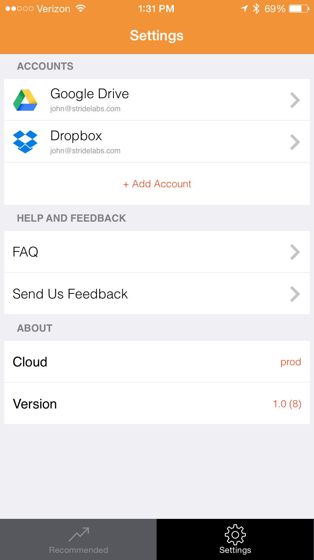  
  
*Recommendations and Sorting*:

* Recommended:  We present you the 50 files that you care about.   How do we do this?  First, we look at which files you have edited and modified.  Secondly, we look at the files that your co-workers are using.  Based on these two groups of files we come up with our recommended list.
* Last Modified:  We give you a list of the top 50 files that anyone has modified across the different file services that you use.  Our goal is that Stride Recommended list is more valuable to you.

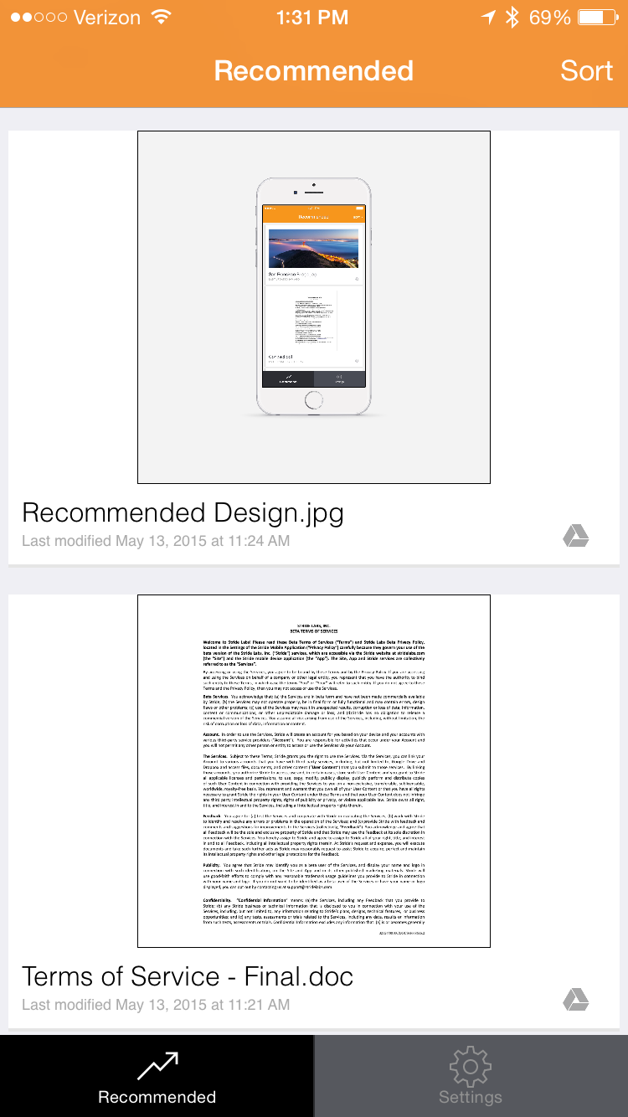  
  
*File Operations:*

* Thumbnail Preview:  We should you a image of the first page of the file.
* Preview:  Click on a file and we will download it into a format that you can see the file on your mobile phone.
* Actions: Using the iOS actions menu, you can post the file to email, Slack, Docusign and more.

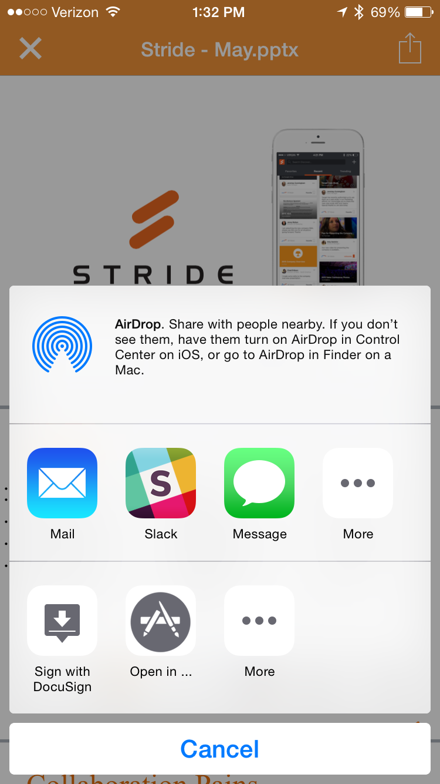  
  
**How Can You Help?**  
Tell us what you like good or bad.  You can send us feedback in the application or send me an email directly.  Most importantly, I want to hear from you what features we should add to Stride.  Please let me know what are the top three features you would add to Stride.  
  
**Our Commitment to You**  
We are 100% committed to building a great product for you.  As part of the service, we take security and privacy very seriously.  The Stride team has been fortunate to work for 10+ years delivering email and collaboration to over 100m people globally.  As part of this experience, we remain committed to delivering a great service and doing so while keeping security and privacy top of mind.  The details of our Privacy Policy and Terms of Service are in the FAQ of our application.  
  
Thank you for offering to be part of the Beta and I look forward to getting your feedback!  
  
- JR and the Stride Team